

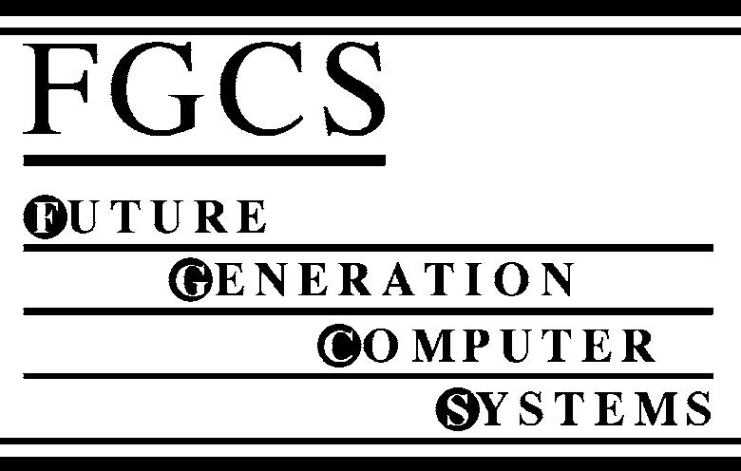

Future Generation Computer Systems 22 (2006) 688–698

www.elsevier.com/locate/fgcs

GMPLS-based service differentiation for scalable QoS support in all-optical
Grid applications

Francesco Palmieri∗

Universit`a degli Studi di Napoli Federico II., Via Cinthia 45, Complesso Universitario Monte S. Angelo, Napoli, 80126, Italy
Received 6 September 2005; received in revised form 19 November 2005; accepted 21 November 2005
Available online 9 January 2006

Abstract

In the forthcoming new era of truly distributed computing, industry, businesses, and home users are placing complex and challenging demands
on the transport network, now powered by the emerging photonic technologies, about Quality-of-Service (QoS) assurances that are required for
new real-time computing and storage service applications geographically distributed worldwide according to the Grid model. There is the need to
devise mechanisms for QoS provisioning in IP over WDM networks that must consider the physical characteristics and limitations of the optical
domain to ensure the proper treatment of service classes when passing from the electrical switching to the optical domain and back. In addition,
these mechanisms should be directly accessible to Grid applications to make them able to request and release network resources as they need.
A (G)MPLS-based control plane combined with a wavelength-routed optical network is seen as a very promising approach for the realization
of transport infrastructures for the future “photonic empowered” Grid computing paradigm, since it allows native user-controlled bandwidth
resources and class-of-service provisioning, that is one of the strongest requirements for truly distributed computing. Considering this, we propose
a general framework for providing differentiated services QoS to Grid applications in wavelength-routed photonic networks, built on the strengths
of GMPLS for dynamic path selection and wavelength assignment. This framework makes it technically and economically viable to think of a set
of computing, storage or combined computing storage nodes coupled through a high-performance optical network as one large computational and
storage device.
c 2005 Elsevier B.V. All rights reserved.

Keywords: Grid computing; GMPLS; QoS; DiffServ; Optical transport networks; WDM

1. Introduction

Over the past years, it has become evident to the technical
community that computational resources cannot keep up with
the demands generated by some processing and data storage
bound applications. Furthermore, the Internet, with the IP
protocol as the most predominant networking technology, is
evolving from best-effort service toward a differentiated service
framework with QoS assurances which will be necessary
for these applications, such as real-time particle physics
experiments or radio astronomical image processing that
produce more data than can be realistically processed in a
reasonable time and stored in one location. In such situations
where time-bounded intensive computation analysis of shared

∗ Fax: +39 081 676628.
E-mail address: Francesco.Palmieri@unina.it.

0167-739X/$ - see front matter c 2005 Elsevier B.V. All rights reserved.
doi:10.1016/j.future.2005.11.003

large scale data is needed, one can try to use accessible
computing and eventually storage resources distributed in
different locations, according to the Grid model. Distributed
computing and storage is not a new paradigm but until a few
years ago networks were too slow, and the early days’ best-
effort networking paradigm was not adequate to allow efﬁcient
use of remote resources. As the speed of networks increased
and technical strategies for differentiation in service delivery
became available, the interest in distributed computing has been
taken to a new level. Thus, scaling the network and delivering
bandwidth and services when and where a customer critical
application needs it, are absolute prerequisites for success.
A new network foundation is required, that will easily adapt
to support the rapid growth, change and highly responsive
service delivery required by Grid computing. In this scenario,
the wide deployment of point-to-point wavelength division
multiplexing (WDM) transmission systems in the Internet
infrastructure has enhanced the bandwidth available in the

F. Palmieri / Future Generation Computer Systems 22 (2006) 688–698

689

network core by several orders of magnitude, introducing the
need for faster switching in the optical domain. Consequently
massive interest has focused on optical networking such
that the answer to all the current performance open issues
is conceived to lie in an intelligent dynamic photonic
transport layer deployed in support of multiple, global,
next generation Grid applications that are being designed
and developed as highly asymmetric, highly distributed and
resource intensive (e.g., computationally intensive, bandwidth
intensive, etc.). New optical devices like WDM Multiplexers
and Optical Cross-Connects (OXCs), and new control-plane
protocols such as Generalized Multi-protocol Label Switching
(GMPLS) [1] will make possible a pure photonic network
where packets are routed through the network core without
leaving the optical domain. The wavelength routing technology
is considered extremely promising for the realization of new
generation networks that will have to handle a signiﬁcant
portion of Grid applications’ trafﬁc, demanding speciﬁc
resources such as assured QoS. These applications must have
powerful and ﬂexible network integration capabilities for
directly discovering and signalling for use of the networking
resources that they require, triggering the dynamic provisioning
of virtual trafﬁc tunnels throughout the network, such as
multi-wavelength lightpaths and multi-domain (electronic and
optical) label/lambda switched paths (LSPs). In addition,
there is a need to devise the proper mechanisms for QoS
provisioning in wavelength routed networks that consider the
physical characteristics and limitations of the optical domain
without any loss in ﬂexibility and performance. The best
solution, at our advice, is applying optical technologies and
electronic technologies in different spheres by implementing
QoS at the edge of a network with electronic technologies
and mapping the resulting QoS service classes into separate
lightpaths in the network fully-optical core. In this paper
we present a general framework for providing differentiated
services QoS in photonic-based Grid infrastructures built on the
strengths of GMPLS for dynamic path selection and wavelength
assignment. State-of-the-art optical networking technology
based on dynamic wavelength switching enables the creation
of Grid services that allocate and release these paths either on-
demand or by advance reservation. Speciﬁcally, we focus on
the edge lambda switching routers (LSRs), located between
label (electronic) switching domain and lambda (optical)
switching domain. All the QoS requirements of the client Grid
applications located on the network edge, and consequently
committed in the label switching domain, will be fulﬁlled
by the appropriate allocation of particular wavelengths on
concatenated physical resources, or lightpaths, in the lambda
switching domain. This framework makes it technically and
economically viable to think of a set of computing and storage
nodes connected through a high-performance optical network
as one large computational device so that the boundaries
between applications, computers, and networks truly dissolve.
The paper is organized as follows. Section 2 introduces the
technological scenario and the most important prerequisite
concepts while Section 3 presents the main architectural details
such as the transport network model and the Grid Service

interface. Section 4 explains the QoS provisioning scheme that
is analyzed through extensive simulation in Section 5, followed
by the related works Section 6.

2. Basic concepts

This section introduces some of the basic concepts that will
be useful to better explain our framework.

2.1. High-performance Grids

High-performance Grids are part of a next generation
“cyberinfrastructure”, often used for extremely large-scale,
resource intensive applications. These Grids are “persistent
environments that enable software applications to integrate
instruments, displays, computational and information resources
that are managed by diverse organizations in widespread
locations” [2]. Some emerging Grid infrastructures, such as the
TeraGrid [3], use networks not for standard communications
support but as backplanes for high-performance computational
clusters, comprised of hundreds or thousands of individual
compute nodes within widely distributed clusters. Other
emerging infrastructures envision global services based on data
communications infrastructure that is primarily dependent on
layer 2 transit end-to-end as opposed to routed paths. The
“Global Lambda Grid” [4], a concept that is being formulated
by the StarLight community, envisions a Grid infrastructure
based on world-wide wavelength data communications
supporting multiple advanced applications, including high-
performance computational scientiﬁc research, high-energy
physics, engineering, bioinformatics, high-resolution medical
imaging, materials sciences, data streaming, digital media,
data mining, and astrophysics. The use of the available ﬁber
infrastructure for the future global Grid transport network
is an attractive proposition ensuring global reach and huge
amounts of cheap bandwidth. In the last years, ﬁber networks
have been great enablers of the World Wide Web services
fulﬁlling the capacity demand generated by Internet trafﬁc
and providing global connectivity. In a similar way optical
technologies are expected to play an important role in creating
an efﬁcient infrastructure for supporting distributed computing
and bandwidth hungry Grid applications.

2.2. The evolution of transport networks suitable for Grids

An important consideration that would inﬂuence optical
Grid network architecture is the choice of switching technology
and transport facilities. Due to the nature of the applications
supported by global Grid computing, suitable network
infrastructures are required to offer a set of features that
are very different compared to traditional telecommunications
infrastructures. In telecommunications networks, when a
trafﬁc demand arises, independent of the transport protocol,
the routing mechanism or the associated algorithms used,
there is always a predetermined pair of two discrete points
that need to communicate in order to satisfy the trafﬁc
demand. This is fundamentally different in Grid scenarios,

690

F. Palmieri / Future Generation Computer Systems 22 (2006) 688–698

in which a particular end user or application may require
to access computational or storage resources distributed on
the network and needs to identify the availability of network
resources to reach them. In this case only the source point is
predetermined, while the destination has to be discovered and
identiﬁed using intelligent mechanisms supporting advanced
signalling schemes. An additional fundamental difference of
Grids compared to conventional telecommunication networks
relates to the bidirectionality of connections. In traditional
telecommunication networks connections are most commonly
bidirectional and the two directions demonstrate strong
symmetry characteristics. In the Grid paradigm the two
directions are also required. One direction enables the source
to discover and access the network resources in order
to submit a job or request for a data set. The opposite
direction is required in order to extract the results or the
requested data and deliver them to the user. However, the
two directions can be decoupled and set up independently
since, due to the network scenario and resource allocation
scheme they may have a different set of requirements and
features. The main issue while designing optical networks
for distributed computing application is specifying the right
transport and control facilities. The transport networks on
which the actual distributed computing applications run are
evolving from the traditional TDM paradigms, with WDM
used strictly for ﬁber capacity expansion, toward pure WDM-
based optical networks with transport, multiplexing, routing
supervision, and survivability handled at the optical layer.
These optical networks, to provide the infrastructures required
for Grid applications, must be based on a distributed and
ﬂexible control plane allowing control and ownership of
network resources by the users, in contrast to traditional
telecommunications networks. The key concept to guarantee
desirable speeds and correct functional behavior in these
networks is to maintain the signal in pure optical form,
preferably onto the same wavelength, thereby avoiding the
prohibitive overhead of conversion to and from electrical
form or between different wavelengths. In this scenario, given
that the IP protocol framework will become the dominant
form of data transfer, there is an increasing interest in the
implementation of “Grid-aware” IP over photonic networks by
using the wavelength-routed networking paradigm and placing
Grid data services directly on WDM lightpaths. A very large
consensus is also emerging on utilizing an IP-centric control
plane within optical networks to support dynamic provisioning
and restoration of lightpaths. Speciﬁcally, we assert that
the GMPLS-based control plane, combined with DWDM
technology, makes it possible to provide an effective framework
for optical bandwidth management and real-time provisioning
of QoS-bound optical channels in an automatically switched,
transparent optical network suitable for next generation high-
performance distributed computing applications.

3. Optical transport infrastructures for Grids

In optical network infrastructures supporting Grids, high
bandwidth users and applications must manage and control

network resources, in a distributed and truly peer-to-peer
manner. The optical transport networks must support bandwidth
manipulation at the wavelength level through wavelength
switching technologies, offering not only high switching
granularity but also the capability to accommodate a wide
variety of trafﬁc classes, characteristics and distributions.
Novel control plane designs and hardware solutions ensuring
the programmability of the network infrastructure can
facilitate dynamic control of bandwidth and service classes
to support new application-oriented and user-owned network
infrastructures. In these networks resource request, discovery
and allocation functions have to be performed initially when
a processing requirement (i.e. bandwidth demand) arises.
For example if a certain number of users (or applications)
have jobs to be posted on the Grid, each one constructs a
“request” indicating the amount of processing and the class
of service required. These requests, translated in terms of
network resources and QoS needs by the proper Grid-to-
network interface middleware, are received by the ingress point
at the edge of the network (typically hybrid optical routers,
performing optical-to-electrical (O/E) and electrical-to-optical
(E/O) conversions) and assuming that the total volume of the
data to be processed is large enough, a bandwidth and QoS
request arises at the optical layer. In the case of acceptance,
the data itself is immediately allowed in the network making
use of available resources i.e. wavelengths. The intermediate
optical switching nodes (typically OXCs), making up the “core”
of the optical transport network, are not notiﬁed in advance of
the arrival (i.e. there is no advanced reservation), but decide on
the ﬂy where to forward the data. These intermediate nodes will
clearly require some application and network-level awareness
in order to conﬁgure the resources that are best suited for the
particular task. The above connectivity service may be provided
over a private or public shared network (like the Internet)
owned by a large enterprise or a consortium (a Grid consortium,
for example) or spanning many different service providers
or carrier organizations. Anyway, to facilitate on demand
access from Grid applications to the optical transport network
and consequently to the speciﬁc Grid services, interoperable
procedures between Grid users and the optical network for
service-level agreement negotiation and user job submission
have to be developed. These procedures constitute the so-
called Grid User Network Interface (GUNI). Since the Grid
infrastructure and services are usually managed by a resource
management system or middleware, such as Globus, the GUNI
interface is usually integrated within this middleware stratum.
The GUNI also provides a simple signalling mechanism
between Grid users and the optical network following the
indirect service invocation scenario, in which the users request
the network edge devices for a Grid service (i.e. bandwidth
reservation or service class) through a Grid service agent. This
agent performs the above functionalities by sending proper
control parameters/action codes to the network edge devices
according to a well deﬁned protocol.

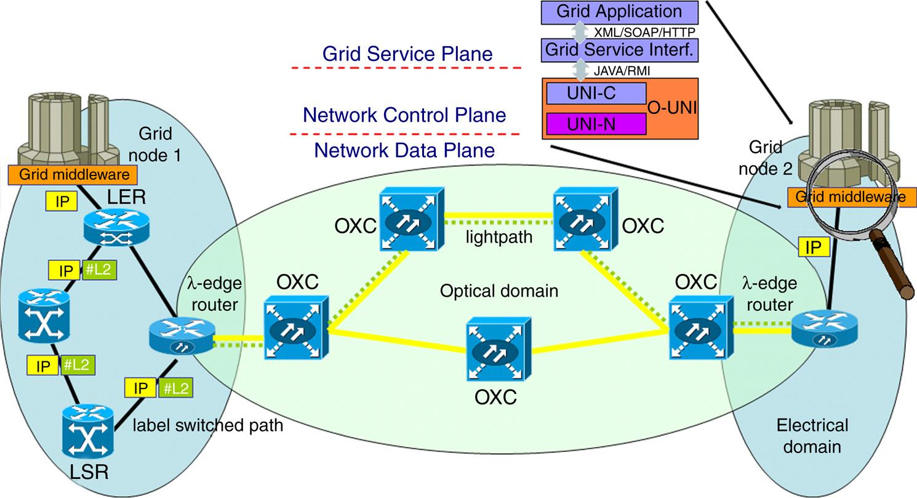
F. Palmieri / Future Generation Computer Systems 22 (2006) 688–698

Fig. 1. The GUNI architecture.

691

3.1. The GUNI architecture

The Grid applications typically need to allocate and reserve
multiple types of resources, such as computational, data,
instrumentation, and locally scoped networks, at distributed
sites. To enable the efﬁcient use of optical networks as a
primary resource for these applications, a powerful paradigm
for the reservation and dynamic allocation of individual
wavelengths, directly available into the Grid middleware,
is required. This paradigm should rely on a new network
service, made available through the GUNI, providing options
for requesting, allocating and releasing dedicated network
resources to Grid applications. This service must explore the
availability and optimize the schedule of the optical network
resources hiding to the client all the transport network topology
and engineering details. It should also present a ﬂexible,
high-level interface to make the optical network infrastructure
accessible through the Grid middleware. A natural choice
for implementing this interface on the Grid host site is the
Web Service Resource Framework (WSRF) [12] aiming at
implementing some of the Open Grid Service Architecture
(OGSA) core services as Grid services, or better, web services
enhanced for Grid applications. Such interfaces are compliant
with the GGF’s OGSA speciﬁcation [11] and, in addition,
conform to widely used Web Services standards (WSDL,
SOAP, and XML). On the hosts participating to the Grid, any
given optical lightpath and its associated QoS capabilities could
be modeled as a Grid service in a service oriented architecture
like OGSA and implemented by using, for example, the
Globus Toolkit v3 OGSA [11] as the development platform.
An end-to-end lightpath requested by the Grid users could be
treated as a network enabled entity, which provides a particular
QoS capability. These capabilities will be deﬁned within a
WSDL ﬁle, where a client of the QoS-aware lightpath service
will be able to discover and invoke supported operations. To
break down the complexity, maintainability, development and
operational sustainability of the GUNI model, its architecture
can be conceptually divided into two tiers — the top level

one, the Grid Service Interface, directly providing service to
Grid applications, and the Optical Network Interface, providing
access to the underlying transport network, as depicted in Fig. 1.
As a simple example we can deﬁne the application-
level interface for the basic end-to-end lightpath on-demand
allocation and deallocation service. It should allow the
application to specify parameters of the desired optical path
that are relevant at the application level, while hiding the details
of the underlying network topology and network management
protocols. Two methods need to be exposed to the user: Path-
Request and Path-Release. The method Path-Request requests
a new path between two end hosts. The path allocated should
meet the criteria speciﬁed in the parameter object passed
to the method. These parameters may include the network
addresses of the hosts to be connected, the minimum acceptable
bandwidths, the maximum delay, or Bit Error Rate (BER) and
the maximum duration of the allocation. The Path-Request
method returns to the caller an object containing descriptive
information on the path that was allocated. This object also
serves as a handle for the Path-Release request and in a
very simpliﬁed implementation may also be used to mark,
via the DiffServ DSCP ﬁeld, the Grid trafﬁc that will be
explicitly routed on the speciﬁc path. This allows simple trafﬁc
classiﬁcation and marking activities to be done at the GUNI
level, enabling Grid users (or applications acting on their
behalf) to directly micromanage network capacity and service
class allocations at the Grid middleware level. Such a service
can be implemented in a way that does not maintain any session
or context information for any particular client between calls.
The only necessary context information is the allocated path
identiﬁer, which the client is required to supply in order to
deallocate a path. The service must maintain this information
about these allocated paths so, in this sense, it is not “stateless”,
but each client call can be treated as a self-contained unit and
processed entirely in a single-message exchange. Thus, the
interface ﬁts the service oriented architecture of Web Services
quite closely.

692

3.1.1. The network service interface

F. Palmieri / Future Generation Computer Systems 22 (2006) 688–698

automatically provisioned between two edge routers with

Since the underlying transport network is usually neither
owned nor under the control of the Grid organization we need
an architecture where the interfaces between Grid network
sites and the optical transport network is standardized and
widely supported from network equipment manufacturers.
In the proposed GUNI architecture, access to the optical
transport network control plane will be available through an
optical user-network interface (O-UNI) standardized by the
Optical Internetworking Forum (OIF) [13]. O-UNI deﬁnes the
optical interface between the service provider (optical transport
network) and user client equipment, allowing a client at the
edge of the network to signal for a connection to be set
up or torn down. GMPLS will be used for client signalling.
O-UNI functionalities have been implemented in UNI 1.0 [14]
that speciﬁes the set of services, the signalling protocols
used to invoke the services, the mechanisms used to transport
signalling messages and the auto-discovery procedures that
aid signalling, all of which are to be implemented by client
and transport network equipment vendors to support UNI 1.0.
UNI 1.0 mainly focuses on signalling protocols such as RSVP
(resource reservation protocol) [7] and CR-LDP (constraint-
based label distribution protocol) [8] for service invocation
and resource reservation. Proposed parameters available to
the O-UNI include destination port, QoS, protection level,
bandwidth, and route diversity. The interconnection model of
our GUNI, interfacing the standardized O-UNI is an overlay
model, with indirect service invocation conﬁguration, Here,
UNI-N (UNI Signalling Agent – Network Side) and UNI-C
(UNI Signalling Agent – Client Side) components are needed
at both sides, respectively on the Label Edge router (LER)
and on the Grid interface. The purpose of the overlay model
(O-UNI/GMPLS) is to enable the client (the Grid service
requester) to add, modify, or delete connections to the carrier
network, without providing the client any visibility to the
carrier’s network topology. The overlay model maintains a
separation at the client-to-network interface by keeping the
IP client routing, signalling protocols, topology distribution,
and addressing scheme independent from the ones used by the
optical layer of the carrier network.

3.1.2. The communication paradigm
Communication between the Grid applications and the
GUNI top level service interface will take place via
SOAP/HTTP using well-deﬁned extended WSDL Grid Web
service interface [15]. Requests and responses conform to
WSRF Web Services speciﬁcations, i.e., they are SOAP
messages, carried in HTTP envelopes and transported over
TCP/IP connections. The Grid Service Interface can announce
its services by means of a Universal data base Description,
Discovery and Integration (UDDI). The optical network
services can be made available to the Grid Service Interface
through an OIF UNI 1.0 compliant UNI programmatic
interface library (i.e. Java/RMI), interfacing the Client-side
UNI signalling Agent (C-UNI) available on the Grid host.
Using LDP or RSVP-TE signalling, as deﬁned in UNI
1.0, connections triggered via the UNI-C agents may be
optical interfaces, through the optical network composed of
optical routers and OXCs. As an example, when using LDP
signalling, operation mode in UNI will be downstream on-
demand label advertisement with ordered control and thus when
a new connection is needed, for example, for transmitting
data between two remote Grid applications, the Source UNI-C
(SUNI-C) sends an LDP request message to the corresponding
network interface agent Source UNI-N (SUNI-N). If the optical
network accepts the request, the Destination UNI-N (DUNI-N)
relays the request message to the Destination UNI-C (DUNI-C)
to reserve the required bandwidth. Supposing the reservation
is successful, DUNI-C sends an LDP mapping message to
DUNI-N with the assigned interfaces and labels; if the
optical network commits the assignment, the SUNI-N relays
the mapping message to SUNI-C. When SUNI-C receives
the mapping message, a reservation conﬁrmation message is
forwarded to DUNI-C in a fashion like the initial request
message. After completing the above signalling process, the
Grid application achieves access to the required connection
service through the optical core network.

4. QoS support in WDM-enabled Grid networks

Over the past decade, a signiﬁcant amount of work has
been dedicated to the issue of providing QoS in non-WDM
IP networks. Basic IP, that is the network protocol of choice
for the actual and past low-performance Grid architectures,
assumes a best-effort service model. In this model, the network
allocates bandwidth to all active users as best as it can, but
does not make any explicit commitment as to bandwidth, delay
or actual delivery. This service model is not adequate for
many real-time new Grid applications that normally require
assurances on the maximum delay of transmitting a packet
through the network connecting the end points. Furthermore,
with the recent migration of modern Grid applications from
a Local Area Network (LAN) to a more global Wide Area
Network (WAN) scenario, the need for strong quality assurance
in the transport service has emerged. Indeed, unlike in the local
Grid scenario, in the global Grid scenario applications should
share network resources with a number of heterogeneous
other applications whose required network service may vary
from basic connectivity, like Internet access, to more complex
services, like Virtual Private Networks (VPNs). Particularly, to
support the emerging high-performance computational Grids,
given the intrinsic heterogeneous nature of middleware and user
applications running on them, at least two fundamental Quality
of Service requirements are to be deﬁned.
• Services for minimization of packet loss, packet
instantaneous delay variation and one-way delay:
Applications based on video streaming, voice, or on the
exchange of high-quality images are examples of data-
intensive transactions on the Grid that produce load on
the network but are particularly sensitive to packet loss,
delay and jitter. Remote control is another example of delay
and packet loss-sensitive application, which injects a small
amount of high-priority trafﬁc.

F. Palmieri / Future Generation Computer Systems 22 (2006) 688–698

• Services for segregation of different trafﬁc classes: 4.1. QoS-driven lightpath allocation
Segregation of trafﬁc classes is the capability to provide a

693

given set of QoS guarantees to each trafﬁc class regardless
of the trafﬁc proﬁle injected. This type of service can be used
for example to protect in each Grid site legacy trafﬁc from
data intensive applications like ftp bulk transfers that could
potentially allocate the whole amount of access capacity.
Less-than-best-effort services like the Scavenger service
under deﬁnition for the implementation on the Abilene
network are additional examples of services based on trafﬁc
segregation: they allow production/legacy trafﬁc to use up to
the total amount of link capacity without being impacted by
lower priority data.
A number of enhancements have been proposed to
enable offering different levels of QoS in IP networks;
these enhancements can also be very useful in supporting
differentiation in Grid services. This work has culminated
in the proposal of the Integrated Services (IntServ) [5] and
the Differentiated Services (DiffServ) [6] architectures by
the IETF. IntServ achieves QoS guarantees through end-to-
end resource (bandwidth) reservation for packet ﬂows and
performing per-ﬂow scheduling in all intermediate routers
or switches. DiffServ, on the other hand, deﬁnes a number
of per-hop behaviors that enable providing relative QoS
advantage for different classes of trafﬁc aggregates. Both
schemes require sources to shape and classify their trafﬁc
at the GUNI interface-level as a precondition for providing
end-to-end QoS guarantees. Since Grid trafﬁc will eventually
be aggregated and carried over the core networks (often
the Internet), it is imperative to address end-to-end QoS
issues in WDM networks. However, previous QoS methods
proposed for IP networks are difﬁcult to apply in WDM
networks mainly due to the fact that these approaches are
based on the store-and-forward model and mandate the use of
buffers for contention resolution. Currently there is no optical
memory and the use of electronic memory in an optical switch
necessitates O/E and E/O conversions, strongly limiting the
speed of the optical switch itself. In addition, switches that
utilize O/E and E/O converters lose the advantage of being
fully optical and consequently bit rate transparent. However,
the wavelength domain provides a further opportunity for
contention resolution based on the number of wavelengths
available, the wavelength assignment method and the unique
optical quality characteristics of lightpaths. An end-to-end
connection request carried into a single or multi-hop all-
optical wavelength routed path can experience transmission
errors, delay and packet loss. These parameters and behaviors
provide the basis for measuring the quality of optical service
available over a given path and for deﬁning the classes of
optical transport services made available to Grid applications.
Our real objective is to implement a scalable and cost-
effective transport network architecture able to satisfy their QoS
requirements by decoupling the networking aspects from the
service speciﬁcations. This separation permits one to preserve
the existing infrastructure whenever new services or upgrades
of the existing ones need to be established.
The problem of ﬁnding a route for a lightpath and assigning
a wavelength to the lightpath is often referred to as the
routing and wavelength assignment problem (RWA). The
objective of the problem is to route lightpaths and assign
wavelengths in a manner which minimizes the amount of
network resources that are consumed, while at the same time
fulﬁlling the paths’ QoS requirements and ensuring that no two
lightpaths share the same wavelength on the same ﬁber link. In
general Lightpath allocation algorithms partition the available
lightpaths into different subsets. Each subset is assigned to
a service class. The allocation approaches differ from each
other in the way lightpaths subsets are allocated to service
classes. This allocation can be static, static with borrowing
or dynamic. In the case of static allocation, a ﬁxed subset of
lightpaths is assigned to each of the service classes. The number
of lightpaths in each of the subsets depends on the service
class i.e. higher service classes are allocated more lightpaths.
When borrowing is allowed, different priority classes can
borrow lightpaths from each other according to certain criteria.
However, borrowing in the reverse direction is not allowed
because lightpaths originally assigned to lower priority trafﬁc
may not satisfy the QoS requirements of higher priority classes.
In dynamic approaches, the network starts with no reserved
lightpaths for service classes. The available pool of lightpaths
can then be assigned dynamically to any of the available service
classes, under the assumption that all lightpaths have similar
characteristics.

4.2. GMPLS Label/lambda inferred DiffServ QoS

We propose a GUNI-driven approach to service-differentia-
ted LSP/lightpath accommodation on a pure photonic switching
core and mixed (electronic to optical) edge built on the GMPLS
control plane and Differentiated Services. DiffServ is the basic
building block for providing QoS within the modern networks
and GMPLS has good synergy with the DiffServ paradigm
because of some similarities in their elements, such as the
role of the domain edge and the application of a treatment
throughout the domain. The combination of GMPLS and
DiffServ enables the operator to provide an optical network
capable of supporting services with deﬁned characteristic
requirements throughout the electric and photonic domains
and the ability to deliver them according to modern Grid
applications’ service-level agreements. For such a GMPLS-
based network in which Label Requests are arriving and
departing at high rates, an appropriate control scheme must
be implemented to set up lightpaths for label distribution and
data ﬂow switching in a fast and efﬁcient manner while fully
satisfying the QoS requirements of the transported service
classes. We will adopt a label-inferred QoS scheme for LSP
setup in which all packets entering the LSP will be marked
at the GUNI level with a ﬁxed Class of Service value and
the label associated by GMPLS to the packets speciﬁes how
they should be treated. This also means that all packets
entering the LSP receive the same class of service. Stated

694

F. Palmieri / Future Generation Computer Systems 22 (2006) 688–698

in a more detailed way, each label switching router that
contributes (in the electronic domain) to a hop to the LSPs
has packet scheduling logic (PHB) that meets at each hop
the QoS level deﬁned by the provisioned DSCP. The ingress
label switching router examines the QoS control parameters
passed from the Grid users through the GUNI interface
(that in the simplest case may be directly mapped in the
DSCP ﬁeld in the IP header) and selects a feasible label
switched path that has been provisioned for that QoS level. In
more complex cases, sophisticated additional parameters such
as reserved bandwidth, link quality and lightpath protection
requirements can be negotiated between the GUNI client and
the edge router via proper signalling. Also in this case a
class of service-DSCP mapping should be established prior
to inject the trafﬁc into the transport network. Anyway, each
label switching router in the path examines the incoming
label and determines, with the EXP ﬁeld, the QoS treatment
for the encapsulated packet. When entering the pure optical
domain, the differentiated service operation of the edge lambda
switching router or OXC is characterized by a set of particular
control issues, such as provision of service-speciﬁc guarantees
and fair accommodation of the transported types of services into
corresponding lambdas such that DiffServ QoS in the optical
domain is guaranteed by the appropriate allocation of particular
service class-dedicated wavelengths on concatenated physical
resources. More speciﬁcally, when a Label Request, triggering
a path establishment on a GUNI-request basis, arrives from the
label switching domain to the edge lambda switching router in
the photonic domain, the incoming label determines the QoS
treatment for the encapsulated packet so that an optical network
service is assigned to the packet ﬂow, capable of taking into
account user requirements and available network resources.
Then the basic problem is to ﬁnd a route and to assign a
wavelength to the Label Request that will satisfy the LSP QoS
characteristics. If a wavelength cannot be found on the route
from the source node to the destination node, or if there is
insufﬁcient capacity in the network, then the Label Request
will be blocked. In the edge lambda switching router, the QoS

network can be an LSR, a lambda-edge router with several
WDM interfaces and wavelength conversion capability or a
pure OXC without wavelength conversion capability. The SPF-
based link-state routing algorithm used to dynamically route
the connection requests (OSPF or ISIS, as stated before)
properly crafted for wavelength routing tasks, works on such a
graph which is modiﬁed after every successful connection. The
layered graph, that we can call G, is obtained by expanding
each node in the network into a number of virtual sub-nodes,
one per wavelength, and then by connecting each sub-node
to a wavelength on each incoming and outgoing link. Let us
deﬁne as E the set of edges of this graph. LSRs and LERs
are represented adding some “conversion” super-nodes, that
topologically connect all lambda layers through “ﬁctitious”
links with inﬁnite capacity. If the initial (full) capacity of each
edge is normalized to 1, each time the routing algorithm ﬁnds
a path between an ingress–egress pair in G we modify it by
removing the graph edges traversed by a lightpath and by
adding a direct edge, called cut-through, with capacity equal to
1 − Rb where Rb is the fraction of the link bandwidth required
by the lightpath. The extended graph allows us to model the
wavelength availability per link and the residual bandwidth per
logical link at the IP layer. When an established lightpath is
torn down because the last connection occupying it is ended, the
cut-through arc is removed and the edges in the extended graph
corresponding to the underlying physical links are set back with
full capacity. Each edge in E is weighted by a triplet (Ab, w, c),
where Ab is the available edge capacity (if T b is the wavelength
capacity in bandwidth units Ab = T b means full capacity), w
the associated weight and c the cost metric which models the
signal degradation introduced by the transmission link, and may
correspond to:
• an available wavelength λ on a direct physical link between
two nodes (in this case Ab = T b and c = 1)
• an existent direct (cut-through) lightpath on a wavelength λ
between the nodes. For such an edge
M
∑

condition as well as the capacity and availability of the optical
network resources should be considered. Thus the procedure
Ab = T b −
i=1
Rb_{i}

to set up the LSP in the lambda switching domain is closely
related with the routing and wavelength assignment algorithm.
Within the GMPLS scope, the OSPF or ISIS link-state internal
routing protocols, properly modiﬁed with trafﬁc engineering
and RWA extensions, along with label distribution/signalling
protocols such as RSVP with trafﬁc engineering extension
or CR-LDP, implements the required QoS-aware dynamic
routing and wavelength assignment features, as described in the
following sections.

4.3. The QoS-aware routing and path selection paradigm

According to the above schema, the optical network
consisting of n nodes interconnected by m optical links, where
each link can carry up to k wavelengths, can be modeled
as a layered graph [9], where all the wavelengths on a link
are separated into different graph edges. Each node in the
where M LSPs with required bandwidth Rb_{i}are running
over it and c is set to the number of crossed ﬁber links)
• a ﬁctitious conversion edge between the super-nodes in G
(and thus it has Ab = ∞ and c = 0).
Different wavelength routing policies can be realized by
modifying the w components on the weight triplets of the
edges in E and then by running the Dijkstra shortest-path-
ﬁrst (SPF) algorithm on the extended graph. In fact, these
weights may be used to reﬂect the cost of network elements
such as O/E/O converters (in LSR or LER nodes) or free
wavelengths on some link and to characterize the properties
of different wavelength channels (such as delay, capacity, etc.).
Thus, by modifying the above weighting factors according to
the incoming service class request, it is possible to choose
a path which minimizes the number of conversions or which
maximizes the usage of existing lightpaths. The different
decisions reﬂect different objectives in terms of network

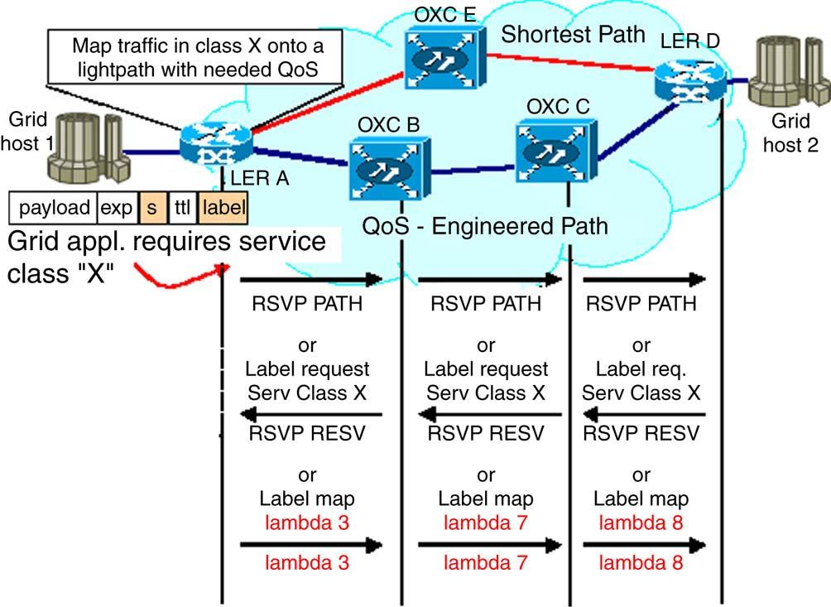
F. Palmieri / Future Generation Computer Systems 22 (2006) 688–698

resource utilization. As a result, a request can be routed over
a direct lightpath (a single-hop path at the IP level), if it crosses
only nodes that cannot perform wavelength conversion between
an ingress and an egress router, or over a sequence of lightpaths
(a multi-hop path at the IP level), if it crosses nodes that
are wavelength conversion capable (lambda-edge or routers as
well). Note that a lightpath in the optical domain corresponds to
a single wavelength crossing a certain number of nodes, without
wavelength conversion. Simply stated, to satisfy a connection
request with bandwidth Rb and class of service q we can
ﬁrst run the SPF algorithm on the above layered graph G by
considering only the edges with residual capacity greater then
Rb and weight w ≤ q; otherwise, if no such a lightpath exist
and a new one has to be set up the SPF algorithm should be
applied on the graph G considering only the edges in E with
cost c = 1 and weight w ≤ q . In the worst case, when all the

695

previous operation does not result in any available direct path,
an indirect path, built on multiple lightpaths all with adequate
capacity and QoS characteristics (as above) passing through a
conversion edge can be chosen.

4.4. GMPLS signalling-driven wavelength assignment

Upon the arrival of a path establishment request, which
is a Label Request indirectly triggered through the GUNI
interface, an edge lambda switching router utilizes the topology
information, gathered from the routing protocol link status
and utilization information to select a route and a wavelength.
Once a route and wavelength are selected with the help of
the SPF algorithm on the above described layered graph
structure, the node attempts to send a Label Request through
the selected wavelength along each link in the route. Thus
the Lambda-Switched paths of a certain service type are set
up and released dynamically, under the quality constraints
related to the optical paths. When exiting from the pure optical
domain the transporting wavelength is naturally re-mapped into
a class of service label (by using the EXP ﬁeld) according to
the GMPLS control plane paradigm and at the egress label
switching router the last label is removed and the packet is
sent to the next IP hop with its original DSCP. This scheme
requires that an association of speciﬁc DiffServ code points to
label switched paths be pre-established prior to trafﬁc ﬂow. This
can be accomplished through proper conﬁguration at the GUNI
interface level. In more detail, when RSVP is used, signalling
takes place between the source and destination routers. At the
source, a Path message is created and sent to the destination
node (see Fig. 2). It may be routed step-by-step according
to the above wavelength routing protocol decisions through
the selected lightpath. Alternatively, an explicit route through
the network may be speciﬁed if the source router is aware
of the network topology. The Path message contains QoS
requirements’ information for the carried trafﬁc and lambda
requests for assigning/reserving wavelengths at intermediate
nodes. On each intermediate node, typically an OXC or LER,
the request is recorded and the Path message is forwarded to the
next node. If the message cannot be forwarded or if resources
are not available, the path setup fails, and a message is sent back
Fig. 2. Lightpath setup with RSVP-TE and CR-LDP.
to the source router. At the destination node, a Resv message
is generated to distribute lambdas/labels, and is sent back to
the previous node. The intermediate optical nodes reserve the
appropriate resources, allocate new wavelengths for the path,
modify the resource availability layered graph kept by the RWA
protocol and send the Resv message back towards the source
router. When the CR-LDP protocol is used for signalling TCP
sessions are established between nodes in order to provide a
reliable distribution of control messages as depicted in Fig. 2.
At the ingress node, a Label Request message is created. The
message indicates the route and the required trafﬁc parameters
for the route. Resources are reserved at the ingress node,
and the Label Request is forwarded to the next node. At
the intermediate node, resources are reserved, and the Label
Request is forwarded. At the destination, resources are reserved
and a wavelength is assigned to the request. The destination
node creates a Label Map message which contains the new
lambda, and passes the message back towards the source node.
Each intermediate node allocates a wavelength, modiﬁes the
wavelength resource layered graph and sets up its forwarding
table before passing the Label Map to the previous node.

5. Performance evaluation and results analysis

In order to evaluate the performance of the proposed
GMPLS/DiffServ-based framework for QoS support in optical
Grid networks, an extensive set of simulation experiments has
been executed. We used the NIST GLASS simulator, which
has been developed for the integrated simulations of Next
Generation Internet (NGI) networking with GMPLS-based
WDM optical networks. It supports the DiffServ-over-GMPLS
paradigm with discrete-event simulations of various DiffServ
packet classiﬁcation, per-hop-behaviour (PHB) processing with
class-based-queuing, GMPLS-based signalling (both RSVP-
TE and CR-LDP) for WDM optical network and ﬁber/lambda
optical switching. NIST GLASS is implemented on the
SSFNet (Scalable Simulation Framework Network) simulation
platform based on a ﬂexible Java-based kernel, an open
source suite of network component models and a smart
management suite. It has been designed and implemented

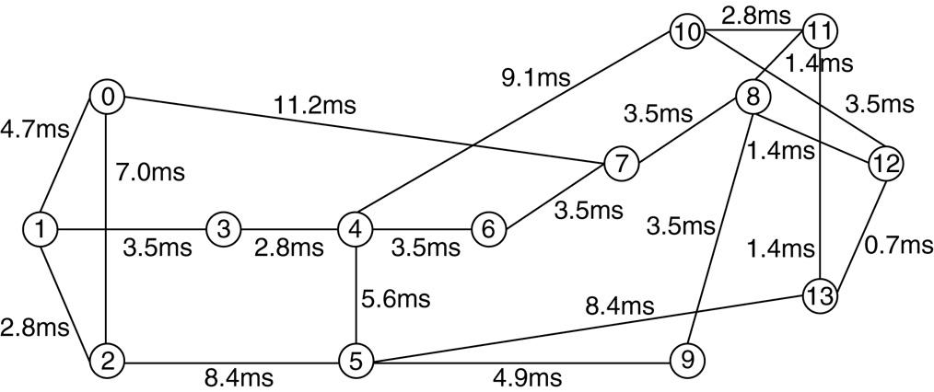
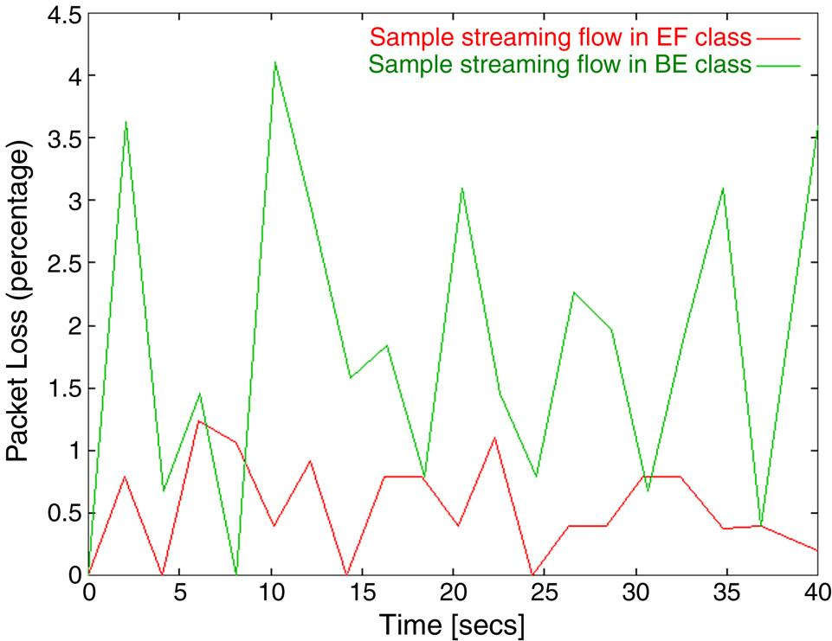
696

F. Palmieri / Future Generation Computer Systems 22 (2006) 688–698

Fig. 3. Sample NSFNet topology used in simulation.

with open interfaces to support expansion or replacement of
protocol modules by users. It uses a DML (domain modelling
language) description input ﬁle interface to support the user’s
ﬂexible deﬁnition/modiﬁcation of simulation parameters and
conﬁguration of protocol modules. Packet classiﬁcation in
SSFNet/GLASS is implemented with a multi-ﬁeld classiﬁer
that uses multiple ﬁelds in the IP packet header (DSCP,
TOS, source and destination parameters etc.) to determine the
differentiated per-PHB treatment for the different trafﬁc classes.
We implemented several modiﬁcations on the OSPF module
according to the multi-layer SPF-based wavelength routing
schema described in the previous Section 4 and created some
simple stub classes, implemented according to the example
presented in Section 3, simulating the GUNI interface for
origin and destination trafﬁc, that for simplicity’s sake has
been classiﬁed, by marking it with the proper DSCP values,
in two macro categories: high-priority trafﬁc, which requires
EF treatment and consequently limited latency, packet loss and
jitter, and normal trafﬁc which can be handled according to
the BE paradigm with no particular QoS requirements. The
stub GUNI interface has also been used to set up bandwidth
commitments on the required end-to-end connections. CR-LDP
signalling has been used for lightpath set up and wavelength
reservation. Simulation has been performed on several network
topologies, both with low and high number of nodes, and thanks
to the consistency of the results obtained, only the graphs
relating to the well-known NSFNet topology reported in Fig. 3
are shown.
The above network consists of 14 nodes and 21 bidirectional
links each composed of 8 unidirectional ﬁbers (4 in each
direction). There are 16 wavelengths, supporting a bandwidth
of 2.5 Gbps, on each ﬁber; 15 carry data, and one is only
used to carry control messages. We assumed that no switches
in the network were capable of wavelength conversion. The
trafﬁc rate given in [10] is used for an initial trafﬁc matrix,
and trafﬁc volumes have been scaled proportionally to the
initial distribution. In order to test the guaranteed provisioning
of bandwidth and QoS parameters, node 9 on the simulation
topology has been chosen to originate most of the trafﬁc
load toward the other nodes, thus forcing the creation of two
bottlenecks on the links between node 9 and nodes 5 and 8
respectively, through which a very large number of lightpaths is
required to pass. The trafﬁc generations have been also imposed
with different timing to simulate a gradually ﬂuctuating
network condition and the link capacities are conﬁgured to be
110% of the sum of the DiffServ packet generation committed

Fig. 4. The packet loss percentage.

data rates; in other words, the link utilization has been kept to
95%. Bandwidth utilization, end-to-end delay, jitter and packet
loss ratio have been measured and analyzed under the above
trafﬁc conditions for both sample high-priority (EF) and best-
effort trafﬁc ﬂows. When analyzing the bandwidth utilization
under trafﬁc congestion on the bottleneck links, as expected
the committed bandwidth on the packet ﬂows with higher
priorities (EF class) was maintained even during congestion
and only the lowest priority trafﬁc (BE) was affected, with
its data rate reduced proportionally to the load (and the QoS
commitments) under congestion. The same considerations may
be done on the measured end-to-end delay on the packet ﬂows
belonging to the two different DiffServ classes used in our
simulation. The higher-priority packet ﬂows were not affected
by the congestion status, while the other ﬂows experienced
gradually increasing end-to-end delay as the trafﬁc increased
through the bottleneck links. Analogously, Fig. 4 shows the
average packet loss percentage measured for the two different
trafﬁc classes.
The observed packet loss values exactly reﬂected the basic
operational properties of the DiffServ-aware framework where
packet loss was kept to the minimum (but not suppressed,
due to congestion condition) for the high-priority trafﬁc ﬂows
and was sensibly greater (but however not unacceptably high,
since we worked on a well provisioned optical network) for
BE trafﬁc. Furthermore, to assess the performance of the
wavelength routing schema, blocking probability has been
analyzed for connections with or without QoS requirements.
In the latter case our RWA wavelength selection algorithm
has been replaced with the one provided in the usual GLASS
OSPF module. Blocking probability has been calculated as a
measure of the number of new connection requests that cannot
be satisﬁed because the required resources are not available.
We maintained two counters that are updated upon the arrival
of each new connection request, one keeping track of the total
number of new connection requests, incremented upon the
arrival of each new request, and the other tracking the number
of failed requests, incremented only when a request fails. The
estimated new connection blocking probability is the ratio of

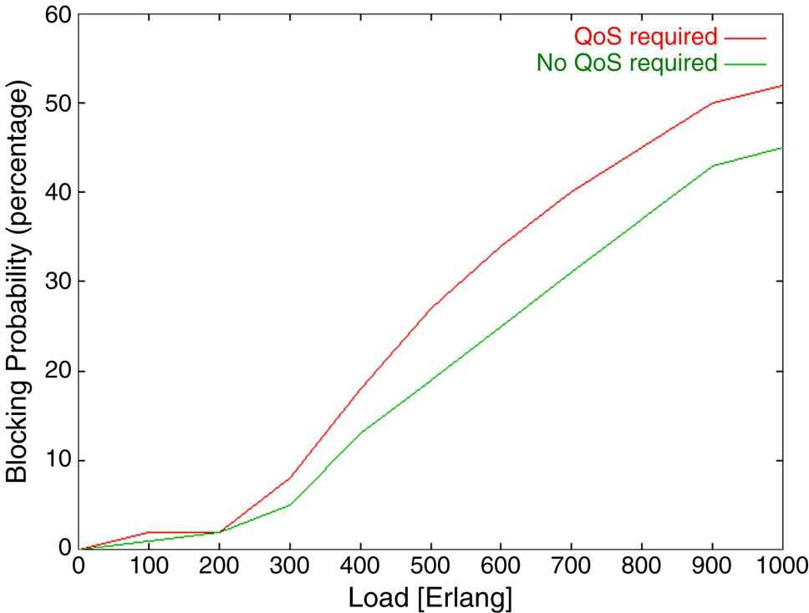
F. Palmieri / Future Generation Computer Systems 22 (2006) 688–698

697

Fig. 5. The blocking probability.

the second counter to the ﬁrst. It is interesting to observe from
Fig. 5 that the measured blocking probability with increasing
load does not exhibit signiﬁcant variations with or without QoS
requirements to be satisﬁed. The blocking probability, when
the network load reaches 200 Erlangs and going on, increases
almost linearly in both the cases (with a slight difference of
about 5%) and at a load of 1000 Erlangs, only about half of
new connection requests are honoured (48% with speciﬁc QoS
requirement and 55% in the other case). This is a very strong
performance indicator for the QoS-driven wavelength selection
paradigm, since the small difference shown at higher loads can
be justiﬁed by the decreasing resource availability, thus it can
be easily seen that the DiffServ-based RWA framework imposes
no signiﬁcant overhead in terms of blocking probability.

6. Related works

Several works focus on providing optical networks to the
Grid community [16,17] and recently, Grid developers used
both IntServ and DiffServ approaches to obtain QoS in packet
switching networks [18–21]. However, IntServ and DiffServ
alone may help in some special cases, but they are far from
perfect solutions, particularly in wavelength switched optical
networks that add further technological complexity to the
already existing integration and interface problems. Some
work has been done in deﬁning an OGSA-based network
service interface to network resources. Another related work
is the DWDM-RAM project [22] that encapsulates optical
network resources (lambdas, lightpaths) into a Grid Service
and thus integrates their management in the context of the
OGSA Architecture. A better approach to the problem of
network resource management in Grids have been introduced
with the General-purpose Architecture for Reservation and
Allocation (GARA) [23]. GARA addresses the issue of advance
reservation by proposing a common framework that can
be applied to different resource types such as computing,
storage and networking. Resource management is integrated
with a variety of general-purpose Grid services (e.g., for
authentication and authorization). However, GARA identiﬁes
the network devices involved in the reservation requests

statically through conﬁguration ﬁles. Consequently, there is
no way for a Grid customer to dynamically discover the
entire range of available network reservation services. Although
advanced bandwidth and QoS reservation is an issue, access to
resources that provides these features solves only one part of the
problem. The complete solution is a new network architecture
with the ability to orchestrate data ﬂows with many different
types of QoS characteristics or service classes, including those
requiring exceptionally high bandwidth or very limited packet
loss and/or jitter for sustained periods of time. In our model,
these high-performance data ﬂows are provided by dedicated
optical paths, which are dynamically allocated on a class of
service basis.

7. Conclusions

We investigated the problem of QoS delivery in the
future wavelength routed networks and presented a general
framework for providing differentiated services QoS to support
real-time Grid applications in wavelength-routed photonic
networks built on the strengths of GMPLS for dynamic
path selection and wavelength assignment. The integration of
Grid architectural concepts with those emerging from next
generation optical networking has just begun. The concept
of optical-network-aware Grid applications signalling, within
the GUNI interface context, their QoS requirements to an
intelligent, dynamically conﬁgured wavelength-based network,
complements the overall objectives and direction of Grid
architecture. This type of integration would provide Grid
communities with powerful new global data path Differentiated
Service QoS capabilities. GMPLS provides the necessary
bridges between the IP and optical layers to allow for
interoperable and scalable parallel growth in the IP and
photonic dimension so that the capabilities offered by the
combination of Differentiated Services and GMPLS features
greatly enhance the ability to control the network to deliver
service according to the Grid end-to-end application Service
Level Agreements and strict QoS requirements.

References

[1] E. Mannie, Generalized multi-protocol label switching (GMPLS)
architecture, in: IETF RFC 3945, 2004.
[2] I. Foster, C. Kesselman, The Grid: Blueprint for a Future Computing
Infrastructure, Morgan Kaufmann, Los Altos, CA, 1999.
[3] D.A. Reed, Grids, the TeraGrid and beyond, Computer 36 (1) (2003)
62–68.
[4] J. Mambretti, J. Weinberger et al., The Photonic TeraStream: enabling
next generation applications through intelligent optical networking at
iGRID2002, Future Generation Computer Systems 19 (2003) 897–908.
[5] R. Braden et al., Integrated services in the internet architecture: an
overview, in: IETF RFC 1633, 1994.
[6] S. Blake et al., An architecture for differentiated services, in: IETF RFC
2475, 1998.
[7] R. Braden, L. Zhang, S. Berson, S. Herzog, S. Jamin, Resource reservation
protocol (RSVP) — Version 1 functional speciﬁcation, in: IETF RFC
2205, 1997.
[8] B. Jamoussi et al., Constraint-based LSP setup using LDP, in: IETF RFC
3212, 2002.
[9] M. Kodialam, T.V. Lakshman, Integrated dynamic IP and wavelength
routing in IP over WDM networks, in: Proceedings of INFOCOM 2001,
vol. 1, 2001, pp. 358–366.


698

F. Palmieri / Future Generation Computer Systems 22 (2006) 688–698

[10] R. Ramaswami, K.N. Sivarajan, Design of logical topologies for
wavelength-routed optical networks, IEEE Journal on Selected Areas in
Communications 14 (1996) 840–851.
[11] I. Foster, C. Kesselman, J. Nick, S. Tuecke, The Physiology of the Grid:
An Open Grid Services Architecture for Distributed Systems Integration,
Globus Project, http://www.globus.org/research/papers/ogsa.pdf, 2002.
[12] K. Czajkowski et al., From Open Grid Services Infrastructure to WS-
Resource Framework: Refactoring and Evolution, http://www.globus.org,
2004.
[13] A. Saleh et al., Proposed extensions to the UNI for interfacing to a
conﬁgurable all-optical network, in: OIF2000.278, 2000.
[14] B. Rajagopalan et al. (Eds.). User network interface (UNI) 1.0 signaling
speciﬁcation, in: OIF2000.125.3, 2000.
[15] A. Iamnichi, I. Foster, On fully decentralized resource discovery in Grid
environments, in: International Workshop on Grid Computing, in: LNCS,
vol. 2242, 2001, pp. 51–62.
[16] L. Smarr et al., The OptIPuter, Communications of the ACM 46 (11)
(2003) 58–67.
[17] D. Vanderster, The Return of circuit switching: A review of user-
controlled lightpaths for Grid computing, Technical Report, University of
Victoria, Canada, 2003.
[18] I. Foster et al., End-to-end quality of service for high-end applications,
in: Network Support for Grid Computing, Computer Communications
(2002) (special issue).
[19] I. Foster et al., A quality of service architecture that combines resource
reservation and application adaptation, in: 8th International Workshop on
Quality of Service, 2000.
[20] G. Hoo et al., QoS as middleware: Bandwidth reservation system design,
in: Proceedings of the 8th IEEE Symposium on High Performance
Distributed Computing, 1999, pp. 345–346.

[21] V. Sander et al., A differentiated services implementation for high-
performance TCP ﬂows, Elsevier Computer Networks 34 (2000)
915–929.
[22] A. Roy, V. Sander, GARA: a uniform quality of service architecture,
in: J. Nabrzyski, J.M. Schopf, J. Weglarz (Eds.), Grid Resource
Management: State of the Art and Future Trends, Kluwer Academic
Publishers, 2003, pp. 377–394.
[23] D.B. Hoang, H. Cohen, D. Cutrell, S. Figueira, T. Lavian, J. Mambretti,
I. Monga, S. Naiksatam, F. Travostino, DWDM-RAM: An architecture
for data intensive service enabled by next generation dynamic optical
networks, in: Proceedings of IEEE Globecom 2004, Workshop on High-
Performance Global Grid Networks, Houston, 2004.

Francesco Palmieri holds two Computer Science
degrees from Salerno University, Italy. From 1989,
he worked for several international companies (i.e.
Alcatel, TeleSoft) on a variety of networking-related
projects, concerned with nation-wide communication
systems, network management, transport protocols,
and IP networking. Since 1997 he has led the net-
work management/operation center of the Federico II
University, in Napoli, Italy. He has been closely in-
volved with the development of the Internet in Italy in recent years, particu-
larly within the academic and research sector, as a member of the Technical
Scientiﬁc Committee and of the Computer Emergency Response Team of the
Italian Academic and Research Network GARR. He is an active researcher
in the ﬁelds of high-performance/evolutionary networking and network secu-
rity. He has published several papers in leading technical journals and at con-
ferences and given invited talks and keynote speeches. He can be reached
at Francesco.Palmieri@unina.it.

